MTC Service Shop Floor PC Installation

- Download the installation package from Box: Box Link
- Log in to the Shop Floor PC as an Administrator.
- Copy the ShopFloorConnect folder to the C: drive of the Shop Floor PC.
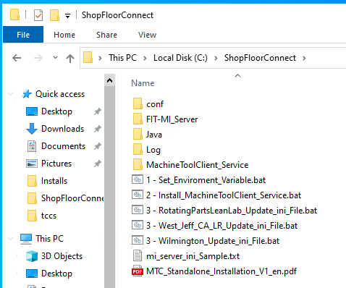
- Run 1-Set_Environment_Variable.bat
- Run 2-Install_Machine_ToolClient_Service.bat
- Run 3-(SFC Server Instance for the site).bat
- Navigate to C:\ShopFloorConnect\FIT-MI_Server\webapps\wut\WEB-INF\conf 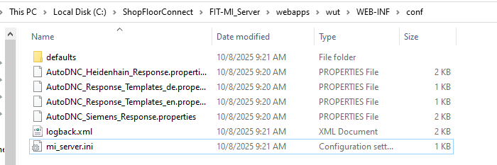
- Open mi_server.ini
- Example only:
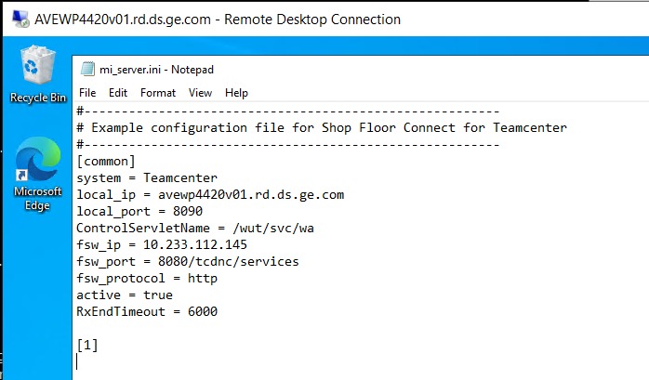
- Verify that the local_ip lists the correct FQDN for the shop floor PC the service is being installed on.
- Verify that the fsw_ip matches the Teamcenter instance the system should connect to.

